Importing data into GeoInsight
The following formats can be used to import custom data into GeoInsight:
- CSV (Comma delimited)
- TXT (tab delimited)
- ESRI shape files
- MapInfo .tab files (must be zipped up)
Data can be in the form of a boundary layer, a points layer (i.e. a customer list), or a polyline layer.

Example for importing a custom MapInfo (.tab) boundary file
A user may have custom boundaries that may represent sales territories/regions, delivery areas, store trade areas etc…
Ensure the file of interest is in .tab format, and zipped up (containing the extensions .DAT, .ID, .MAP, .TAB components). If the file is indexed, you’ll notice a .IND file but this is not required.
>> Data menu >> Import >> File
Click Next >> browse for the .tab file -- make sure the file-type is set to MapInfo TAB (Zipped) (*.zip)
Click Open >>
The file name that is being imported into GeoInsight will be used as the table name.
User Tip! At this stage, it would be helpful to select a descriptive table name if the file name being used is ambiguous or is generalized.
- In the Worksheet box, replace the existing file name with a new table name. This will become the table name that GeoInsight uses within the application (i.e. in Table Management and in the Map Legend).
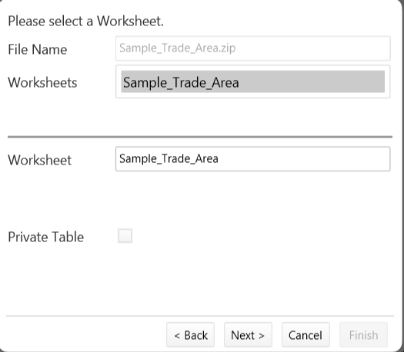

Click Next >>
Use the ID dropdown (under Available Fields) to select a unique ID field within the file; if a unique ID field doesn’t exist in the file, select <unique> in the dropdown (under Available Fields) in order for GeoInsight to automatically create one.
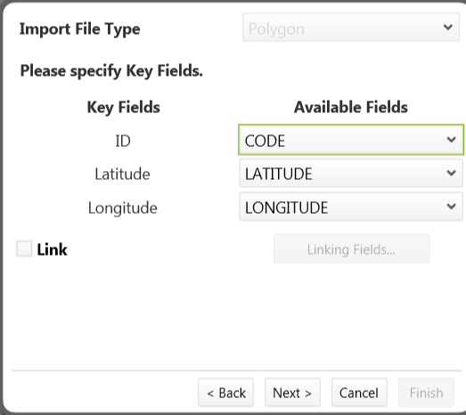

Click Next twice >> from here the imported file will appear in the Map Window and also in the Map Legend window as its own layer.

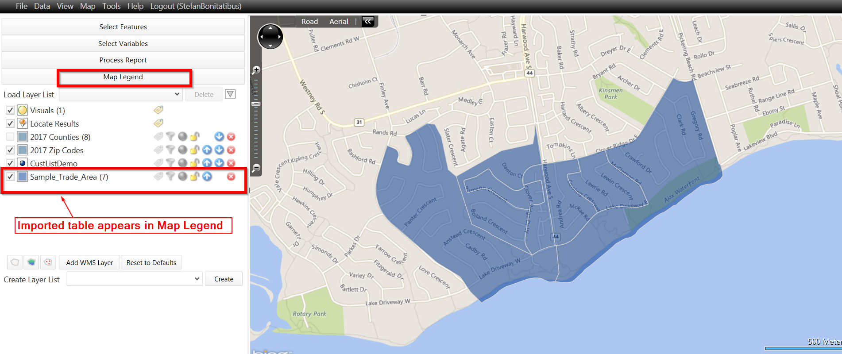

Example for importing a TXT or CSV file
Other types of custom data that users can import include:
- A customer list with address information (with or without coordinates)
- A store locations file (can also be with or without coordinates)
Address records without coordinates can be geocoded during the import process.
Data menu >> Import >> File
Click Next >> Browse for the .txt or csv file -- make sure the file-type is set to the file type of interest
Click Open >> Next
At this stage, the fields contained within the file will be displayed;
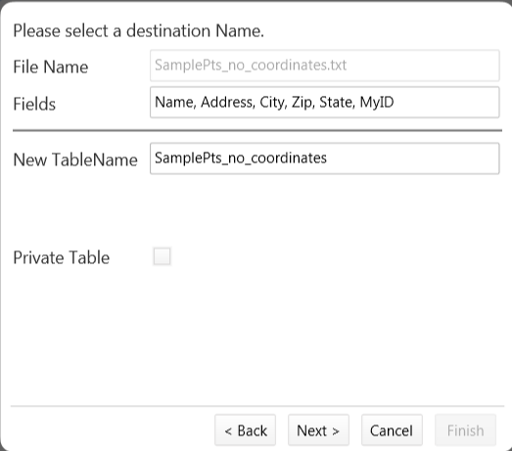
Click Next >>
Use the dropdown arrows to select the appropriate fields. If the file contains Latitude and Longitude fields, GeoInsight may auto-populate these fields. If not, a manual selection of these would have to be completed.
If the file does not contain latitude and longitude fields, the Geocode check-box will need to be selected in order to geocode the file as part of the import process.

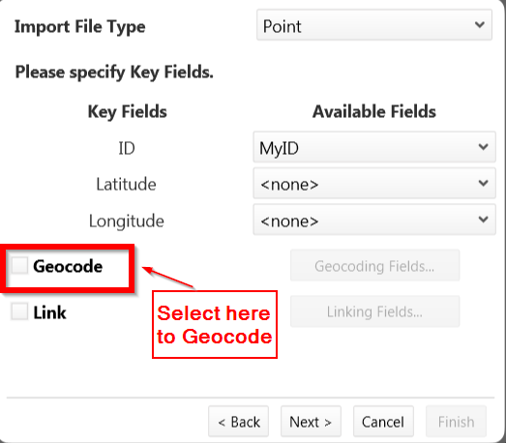
Depending on the available fields (of address elements) within the file, select the appropriate ones using the dropdown arrows.
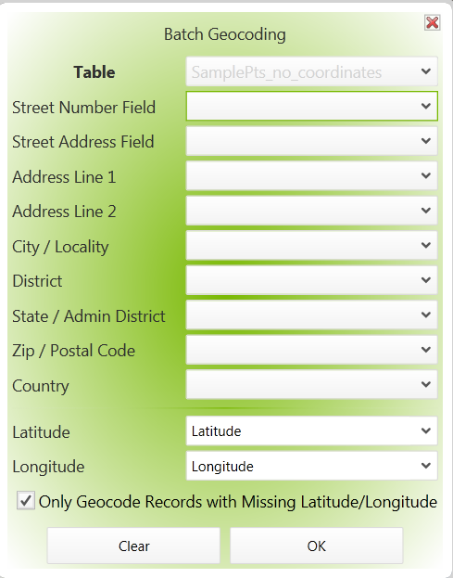
Click Next twice >>
The geocoding process will then begin and once complete, the results will be displayed in a summary box.
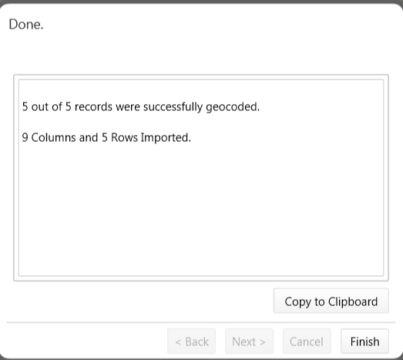
Click Finish >> to complete the import process.
The imported table will then appear as points in the Map Window, and also as a layer name in the Map Legend.

