How To – Use a Variant Attribute Group to Automatically Generate Items
Clients occasionally want Enable to automatically generate items based on product-level attribute value combinations. This can be accommodated when a data model has a 1:M relationship between 2 repositories, e.g. Product and Item.
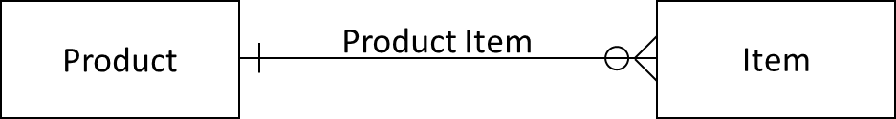
This example employs ‘Product’ and ‘Item’ repositories with a ‘Product Item’ link relationship.
The attributes that control how many Items are generated exist at the Product level. These attributes can be global and/or category-specific, are normally defined as multi-valued, and have associated code sets. They are assigned to an Attribute Group of Type ‘Variant’.
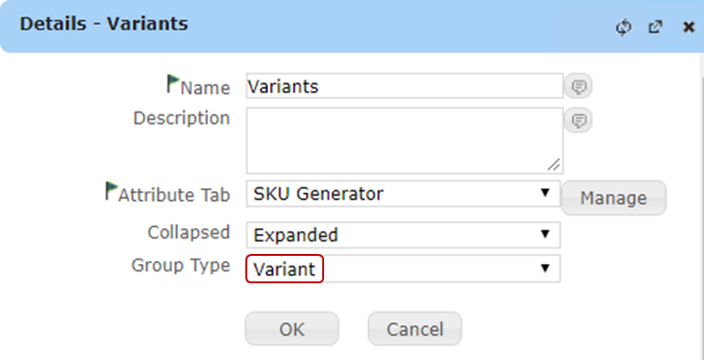
The specific repository, e.g. PreStage vs. Stage or Production, must be defined to ‘Enable Variants'. The link relationship for the 1:M must be selected, and the mapping of product to Item attributes must be defined
Repositories / (select the Product Repository) / Action / Edit / Properties
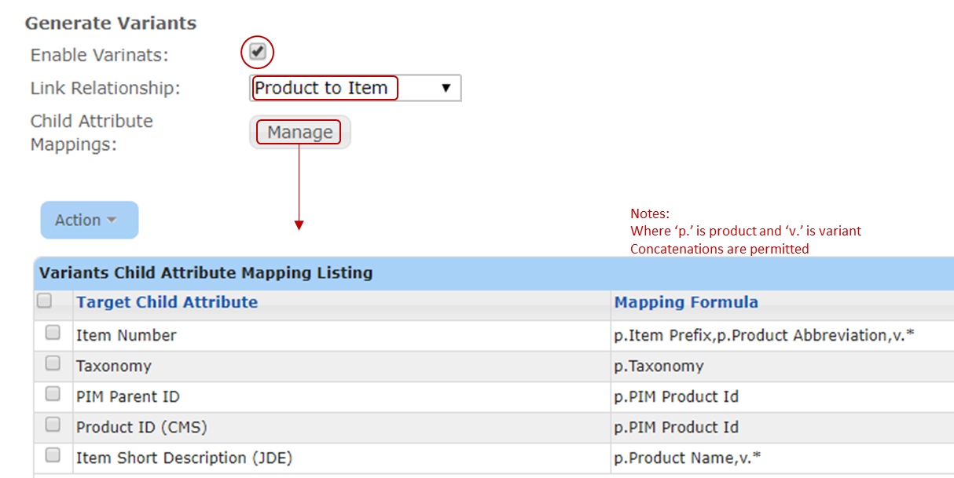

When an Attribute Group’s Type is ‘Variant’ and the repository has been defined to ‘Enable Variants’, an icon appears with the Attribute Group in the UI
Clicking on this icon will initiate the creation of Items based on the values in the attributes in the variant Attribute Group e.g. ‘Variants’.
If the variant Attribute Group ‘Variant’ has 3 attributes:
‘Color’ with 3 values
‘Finish’ with 2 values
‘Lamp Type’ with 2 values
Enable will create 12 Items [3 x 2 x 2].
The new Items are populated with values as mapped in the repository.
Repositories / (select the Product Repository) / Action / Edit / Properties / Manage

