Jayasri Varyani, Sr. Solutions Engineer

PLANNING CONSIDERATIONS FOR A SUCCESSFUL EVOLVE MIGRATION

Contents
Introduction 2
So, what is Evolve? 2
Why Migrate? 2
• Compatibility 2
• Product support availability 3
• Phasing out SharePoint On-Premise 4
• Cloud migration 4
• Integration beyond SAP 5
• Portals 5
• Security 6
• Performance 6
Migration Planning 7
Which version should we install? 7
What are the sizing requirements? 7
How does installation work? 8
Can I run old and new in parallel? 9
Can I have different Studio versions on the same laptop? 9
What about the AFM? 10
What about scripts? 10
What about workflows? 10
How long does it take? 10
Which resources do I need to request internally? 10
What is the level of change for my user community? 11
Is user training available? 12

Introduction
Are you considering an upgrade from Winshuttle Foundation to Automate Evolve?
Are you wondering what the process looks like and what internal and Precisely resources you need to help you navigate this change?
You have come to the right place!
Before we dive in, let us set the stage with a quick overview of Evolve.

So, what is Evolve?
Automate Evolve is the next generation of our Process Automation Platform ‘Foundation’ used by 100s of customers for a variety of mission critical SAP use cases. From an architecture point of view, Foundation relies on Microsoft SharePoint On-Premise, which is being phased out by many IT departments across our customer base.
Back in 2019, Winshuttle (now Precisely) went back to the drawing board and created a new vision and architecture not only to modernize the technology stack and remove reliance on SharePoint, but also to enable a much broader set of Process Automation capabilities for and beyond SAP.
Evolve 20.0 was the first release that focused on feature parity with Foundation, 20.1 came with migration utilities to make the migration faster & painless, 20.2 pushed the envelope with innovation featuring REST APIs and Portals.
Evolve 20.3 has been released which adds support for newer Microsoft releases (Windows 11, Office 2021, Windows Server 2022) and SAP releases (S/4HANA 2022) and other enhancements to improve security and compliance.
We ae working on many more exciting new features such as SAP Fiori automation, so please reach out to your Account Executive to schedule a Roadmap discussion and ask about our early access programs.

Why Migrate?
As it is with many of our customers, you may be perfectly content with your current deployment of Winshuttle Foundation. However, there are still reasons to consider and prepare for the future.
Here are some of the most common compelling reasons:

Compatibility
If you are upgrading your SAP version, whether a newer SAPGUI or migrating from SAP ECC to SAP S/4HANA, it is critical to review System requirements and if necessary, plan to upgrade to a compatible version of Precisely Automate products to stay in harmony and minimize business disruption.
Similarly, on the Microsoft side, if you upgrade your Windows OS (Operation System), Office version or .NET version, it may be technically necessary to upgrade Evolve/Studio as well.
Please review full system requirements for each version here, but here is a helpful snapshot for comparison which highlights key areas where support was added or dropped in each release.

 | Foundation / Studio v12.1 | Evolve / Studio v20.0 | Evolve / Studio v20.3
Operating System | Windows 10 (32/64-bit)  Windows 8.1 (32/64-bit) | Windows 10 (32/64-bit)  Windows 8.1 (32/64-bit) | Windows 10 (32/64-bit)  Windows 8.1 (32/64-bit)  Windows 11
SAP version | S/4HANA 2020 - 755  S/4HANA 1909 - 754  S/4HANA 1809 - 753  S/4HANA 1709 - 752  S/4HANA 1610 - 751  EHP8 - 750  ECC 6.0  ECC 6.0 Non-ERP | S/4HANA 2020 - 755  S/4HANA 1909 - 754  S/4HANA 1809 - 753  S/4HANA 1709 - 752  S/4HANA 1610 - 751  EHP8 - 750  ECC 6.0  ECC 6.0 Non-ERP | S/4HANA 2022 – 757 (with AFM 20.3.1)  S/4HANA 2021- 756 (with AFM 20.2.8)  S/4HANA 2020 - 755  S/4HANA 1909 - 754  S/4HANA 1809 - 753  S/4HANA 1709 - 752  EHP8 - 750  ECC 6.0  ECC 6.0 Non-ERP
SAP GUI  See Which SAP GUI versions are supported by Automate? for details | 760 - patches 1, 2, 3, 4, 5, 6, 7, 8, 9 and 10  750 - patch 10  740 - patch 19  730 - patch 15 | 760 - patches 1, 2, 3, 4, 5, 6, 7, 8, 9 and 10  750 - patch 10 | 770 – patches 1, 2, 3, 4, 5, 6, 7, 8 (patch 8, hotfix 1)  (With AFM 20.2.9)  780 – coming soon
Microsoft Excel or Access | Office 2019 (32/64 bit)  Office 2016 (32/64 bit)  Office 365 (with license type E3 or E5)  Office 2013 (32/64 bit)  Office 2010 | Office 2019 (32/64 bit)  Office 2016 (32/64 bit)  Office 365 (with license type E3 or E5)  For Office 2013 (32/64 bit), limited support for Studio is available. | Office 2021  Office 2019 (32/64 bit)  Office 2016 (32/64 bit)  Office 365 (with license type E3 or E5)  Office 2013 (32/64 bit), limited support for Studio is available.
.NET Framework | 4.6.x  4.5.x | 4.8.x | 4.8.x

Product support availability
Just like other software providers, Precisely phases out older software versions as newer versions are made available. Are you keeping track of ‘End of Life’ dates for your versions?
Here is where to find dates and definitions of ‘Limited Support’ and ‘End of Life.’ See Product Support and General Info (precisely.com)

Phasing out SharePoint On-Premise
This one is easy! Moving to Evolve not only eliminates the reliance on SharePoint On-Premise and reduces the total cost of ownership (TCO), but also simplifies the installation process dramatically.
Evolve has a modern and responsive UI (User Interface), improved ways of managing role-based access and a new module for Reference Data Management which replaces or improves upon SharePoint’s capabilities that were leveraged in Foundation.

Cloud migration
This is one of the most common triggers to consider this migration! Many IT teams want to move all their applications and systems to the Cloud and would prefer a SaaS/hosted offering when available.
As with the deployment options for Foundation, you can host Evolve on-premise or in your private Cloud. But did you know that Precisely can host and manage your private Evolve instance in a single tenant hosted SaaS offering?

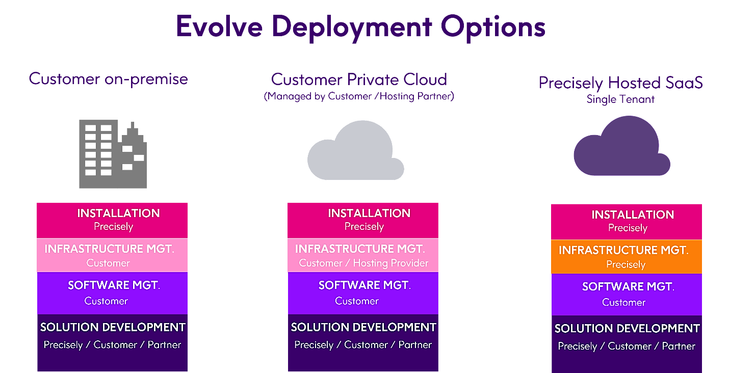

Another common request we get is support for other Database options; so here is a list which includes some PaaS & IaaS offerings in the cloud:
  - Amazon RDS
  - Azure SQL Managed Instance
  - SQL Server on Azure Virtual Machines
  - SQL Server 2019 (64 bit)
  - SQL Server 2017 (64 bit)
  - Supported with SQL Server Always On – High Availability
  - Both Standard and Enterprise edition are supported for SQL server

Integration beyond SAP
If you had integration needs beyond SAP, Foundation allowed for calling external SOAP 1.0 webservices. But times have changed now and so must our development techniques!
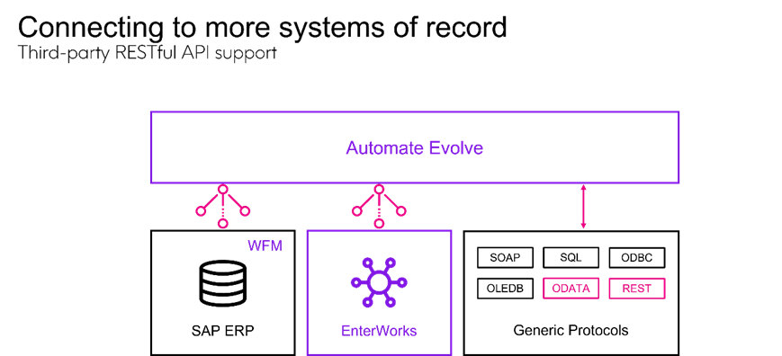
Evolve has a completely new architecture built for modern automation needs and uses REST APIs which opens the doors to many more systems of record.
Evolve also integrates with ODATA APIs, which are REST APIs under the hood. With this capability, the world of S/4HANA is your oyster, whether you use the SAPGUI or not!
If you are an Enterworks customer, you can enjoy native integration and easy data exchange with Enterworks and even combine SAP steps in the same workflow!
Now you can confidently consider automation scenarios spanning systems like Salesforce, SAP PLM, SuccessFactors, ServiceNow, RPA (Robotic Process Automation) and any other software that supports RESTful APIs.
If you are considering Fiori as your primary UI for users, please reach out to your Account Executive to learn how we can help you automate Fiori Apps.

Portals
The Portals functionality was completely driven by customer demand and real-world requirements that we heard repeatedly from our customers.
Now you can securely provision external self-service portals for collaboration and data exchange with third parties like Vendors/Customers/Dealers and accelerate business processes like Vendor Onboarding and Data Maintenance, Joint product launches, Customer Profile Management, Vendor Initiated Pricing Updates etc.,
Keeping with our focus on low-code/no-code software, these portals can be created using a fully customizable widget-based designer and deployed securely without compromising your firewall or access to SAP data.
We have a demo video that walks through the process illustrated below. Please let us know if you are interested in reviewing and we can send you the video.
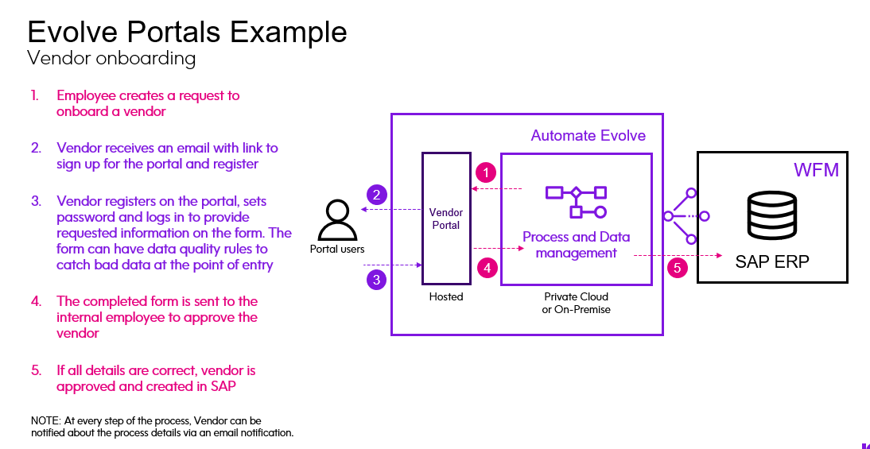

Security
In addition to adding improvements such as FIPS enabled mode, GDPR (General Data Protection Regulation) compliance, better encryption and keeping up with the latest industry standards, Evolve supports a growing list of authentication types & providers.
We support the following SSO providers (as of July 2022):
  - SAML 2.0 (Azure AD, Okta, ADFS, Auth0, Google)
  - OAuth (Azure AD, Okta, ADFS, Auth0)
SAP Authentication types:
SAP SSO authentication:
- Activate SNC, SAP Enterprise Portal (SP Nego), X.509, SAP Trust, SAP SAML
Non SSO authentication:
- SAP Credentials Based, SAP Enterprise Portal (User Creds)

Performance
Yes, webforms are amazing, but sometimes they can get heavy with hundreds of rules and large tables full of data. Thanks to key code improvements and a leaner architecture, webforms on Evolve are 30-50% faster than on Foundation. Ask us for more details on this and we can share best practices for choosing the right UI for your workflow.
Hopefully, this gives you a good summary of the business and technical benefits of migrating to Evolve. The next step is to understand the process and plan for the appropriate resources.

Migration Planning
Like most projects, migration scope, timeline and effort will depend on your current deployment of users, scripts, and workflow solutions as well as future needs. Here are some of the most common questions and answers. Please reach out if you need further clarification.

Which version should we install?
It is always better to install the latest patch version available to get the latest bug fixes.
There are specifically 3 components to the platform.
- Desktop Software – Studio
- Server Software – Evolve Application Server, Worker Server, and Database Server
- SAP certified Add-on - Automate Function Module (previously AFM)
Each version of Studio is compatible only with the same-numbered version of Evolve.
The Function Module (AFM) must be either the same version or an earlier version of client software (Studio) to run and be supported by Precisely. This approach helps with maintaining dual access to old and new environments, more on this later.
To get the full benefits of a release (specifically, the co-dependent new features), the Studio client and the AFM should be the same version.
For example, if you plan to install Evolve v20.2.9, then Studio must be v20.2.9 and AFM is ideally 20.2.9 but can also be a lower version.
Below is the full Studio-AFM compatibility matrix. Automate Function Module - Compatibility Matrix

What are the sizing requirements?
Our product team recommends server specifications and sizing guidelines based on our experience with similar customers. If required post-installation, your IT team can monitor usage and performance and decide to scale up or scale out servers.
Our high usage Production environment sizing is for 400 users (approx.)
Standard Production environment sizing is for 200 users (approx.)
Staging and Development are much smaller and usually sufficient for the use case.
Here is a sample diagram of the standard production architecture:
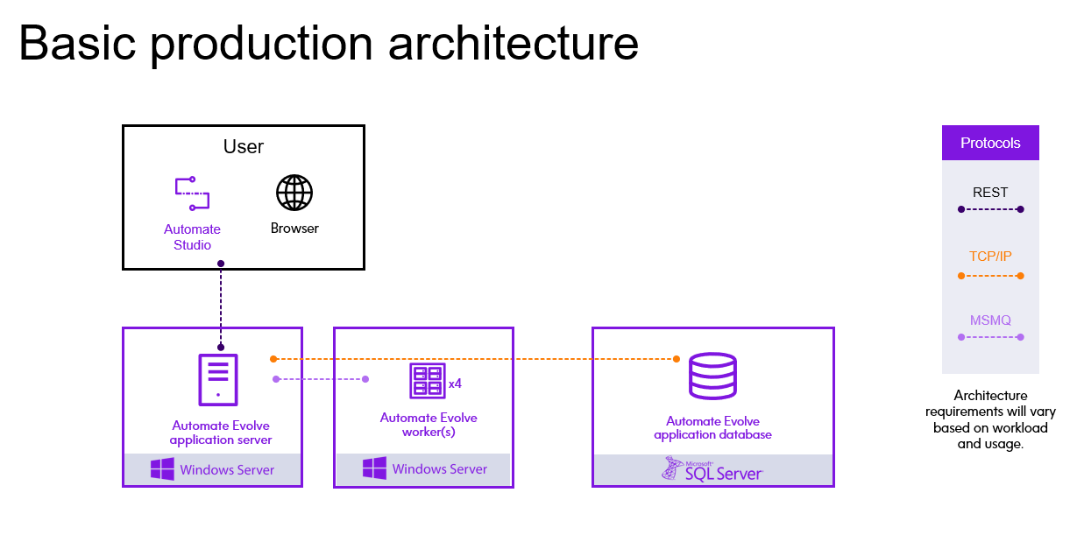
We support High Availability (HA) setup as well and have sizing guidelines for less than 50 and more than 400 users, please reach out to schedule a call with your Account Executive.

How does installation work?
Installation is handled by the Professional Services team at Precisely. It includes the following:
Environment Preparation
  - Products and Architecture PPT
  - Deployment Form – Info gathering for your environment.
  - Environment Readiness Checklist - Prerequisites
  - Accounts and Permissions Checklist - Prerequisites
Environment check-in
  - Finalize architecture.
  - Answer questions
Preinstall Call
  - Go over Evolve Deployment form, readiness checklist, accounts, and permissions.
  - Schedule installation
Install Call
  - Performed remotely over a video call.
  - 2 hours depending on the size of the environment.
Notes:
- The above process takes place prior to User/Admin Training and is repeated for each environment.
- You do not need to provide user accounts in your systems for the Precisely team. We will guide you to perform the installation via screenshare.

Can I run old and new in parallel?
Yes! You can perform this migration while allowing your existing business operations to continue in the current production setup with Foundation.
First, you will need to identify some key users who will help with testing your scripts and solutions in the new Evolve system.
Any testers using excel for running scripts will need a separate virtual machine (VM) where they can install the new Studio client version for testing.
For standard users who will test webforms only, no additional VM is required. They can just open Foundation and Evolve in different browser sessions.
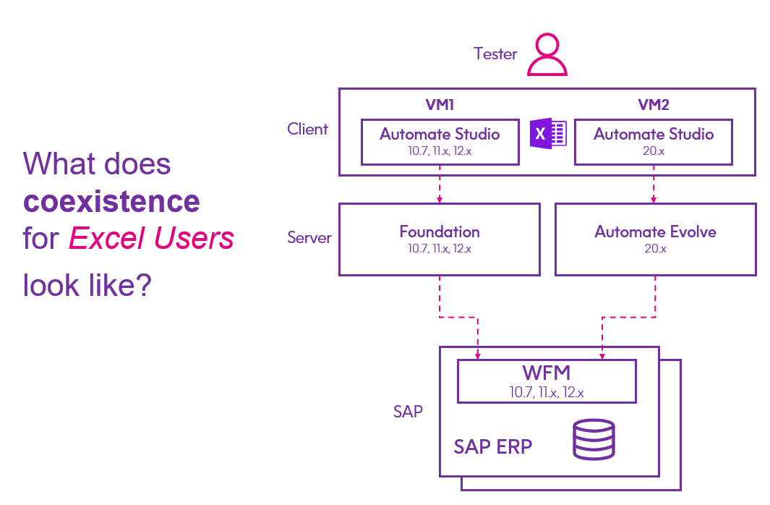
The AFM present on your SAP servers should be left at the older version until you are fully ready to turn off Foundation. If you recall from the section above, Studio is supported with same or lower AFM. For this reason, we need to leave your old production setup (Foundation, Studio, AFM) in-tact while in use.
Once you have migrated and passed testing of the new solutions on Evolve, please schedule time with your BASIS team to upgrade the AFM to the latest version to match your Evolve version.

Can I have different Studio versions on the same laptop?
No. If your testers need access to both versions, they need a separate virtual environment.

What about the AFM?
As discussed before, the AFM should be left as-is (where present). Once you have finished migration testing for Evolve and are ready to go live and fully turn off Foundation, please schedule time to upgrade the AFM on your SAP servers to the latest version. AFM upgrades are fast, do not need server downtime nor trigger long testing cycles.
If you have an SAP system which will be used with Evolve only, you should install the latest compatible AFM 20.x version.

What about scripts?
Scripts must be migrated from Foundation to Evolve. The Script Migration Utility is available for customers to download and use. Here is the migration guide with more information.
https://help.precisely.com/r/Automate-Evolve/20.3/en-US/Automate-Evolve-Migration-Guide/Script-Migration-Guide
Old scripts created in previous Studio versions will continue to work as-is in 20.x Evolve. If you run into any issues, please create a support ticket for assistance.
You can also request a quote for mentoring from our Professional Services team for Script Migration. They can help walk you through the migration utility and help troubleshoot any complex scripts and issues. We recommend this if you have many complex scripts (chained scripts etc.).

What about workflows?
There is a Solution migration utility for workflows as well, which makes the process much easier. However, workflows tend to be more complex and depending on how they were built, there can be areas where additional testing, troubleshooting and adjustments are needed.
https://help.precisely.com/r/Automate-Evolve/20.3/en-US/Automate-Evolve-Migration-Guide/Evolve-Solution-Migration
We recommend engaging our PS (Prof Services) team or a trusted Precisely partner to provide you with estimates for solution migration.

How long does it take?
Well, it depends!
Customers should plan for a Project Manager or a key contact on their side, who can be a counterpart to the Precisely Project Manager and take joint responsibility for a timely project.
Once the servers are ready for installation, the rest of the process steps flow smoothly.
It helps to know that while Precisely allows for 3-6 months of dual access from the time of new license activation for migration projects, most migrations conclude well before this timeframe.

Which resources do I need to request internally?
The resources and their time commitments vary between project stages and depend on your internal processes. Here is a general list of who is involved in the migration project.
Precisely resources
- Project manager
- Installation consultant
- Trainer
- Migration Consultant
Customer resources
- Project manager
- Evolve/Foundation Administrator
- Testers – Business User/Power user/SME
- Required for local installation only:
  - Windows Server administrator
  - SQL administrator
  - Network administrator
- If using SSO, SSO administrator

You can also optionally request a sample project plan from your Account Executive.

What is the level of change for my user community?
The biggest changes from Foundation to Evolve are in how the Administrators setup and manage the system. While in SharePoint, content was organized in Sites and Subsites, Evolve has the concept of Apps and Libraries. The Admin training course is mandatory and covers the necessary material to accelerate setup and configuration of the system.
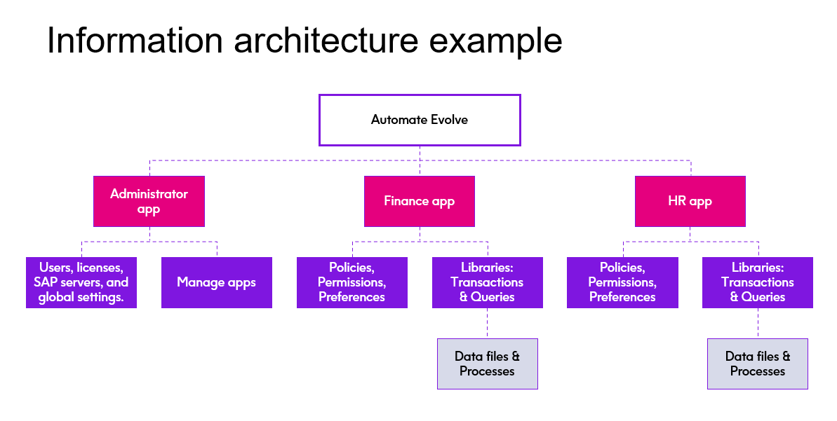Developers who have experience in Studio & Composer experience the same look and feel for designing scripts & workflows that integrate with SAP. They should review release notes and go through online training to learn new features. Please see the training section below for specific links.
Runners and Standard webform users find that the features and functionality are familiar and easy to find. They report a low change rating.

Is user training available?
Yes, plenty of it.
Please register to the Online training platform to access in-depth training modules for developers and runners. Select the ‘Precisely U’ tile on the Precisely Customer Community
The Community is a wealth of information and a great place to ask questions to other users as well as download Precisely published scripts and templates to accelerate your learning.
Here is an ongoing webinar series for training topics that includes advanced Studio and Evolve topics. (A link will be updated shortly as we are migrating all content from Winshuttle to Precisely).
In addition, there are paid virtual live training options available that can be customized to your unique needs.
For more information about licensing costs, migration services or any other technical questions, please reach out to your Account Executive to set up an architecture review call.

