ME52N
Enter the transaction and click the Other Purchase Requisition Button
Enter PR number and click Other Document
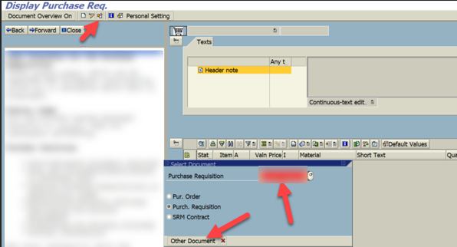
Click Change
Click Personal Settings
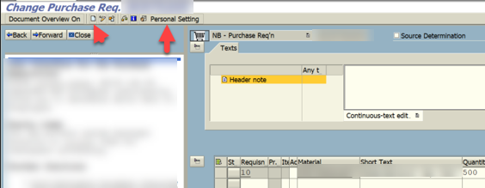

Clear out the Item overview as grid control option
Click Save
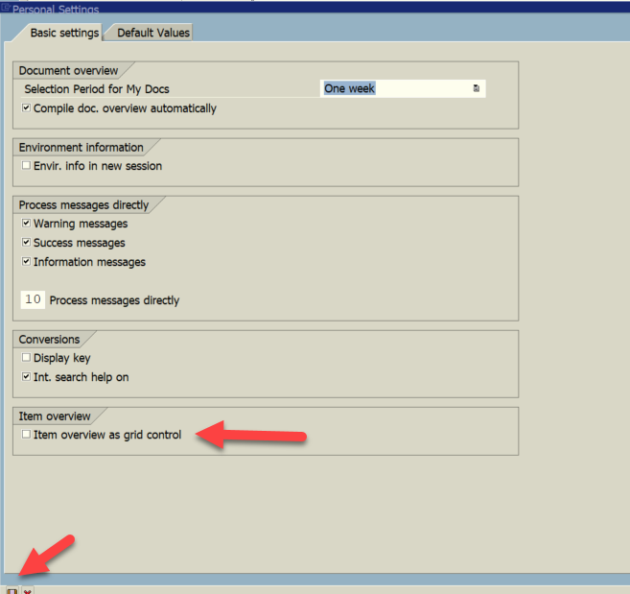

Click Filter option in the middle section
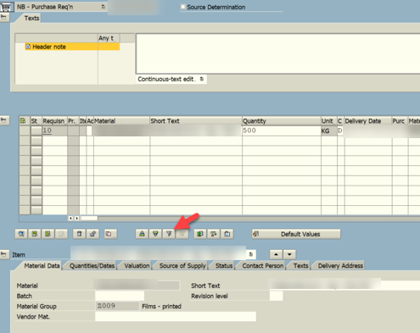

Select each first Column Name and move it to the Filter criteria all the way until Material is moved over
Click Define Values
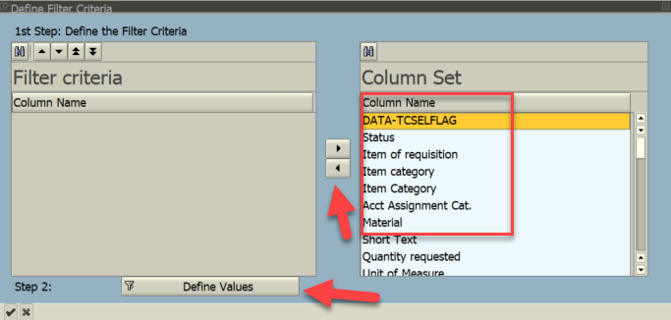

Enter Material Number to update
Click Green Check
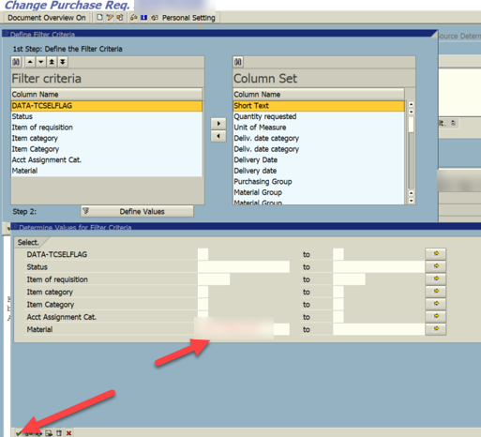

Click the Detail button
Select the Quantities/Dates Tab
Check On or Off the Closed Checkbox
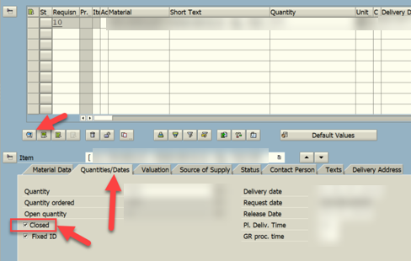

Click Save

