Adding contacts to a business partner

Use Case
We want to add contacts to a business partner. Unlike SAP ECC6, where we simply add contact names to a vendor or customer using transactions XK02, XD02 in S/4HANA, contact persons are themselves business partners. They have to be created in a first step using transaction BP or BUP1 and then in a second step assigned in a relationship to the main business partner.

Solution
This solution assumes that the contact persons have already been created as business partners. We use transaction BUP2 to assign contact persons to a business partner.

Step-by-Step Recording
Start Studio, choose New, Transaction, Recording.
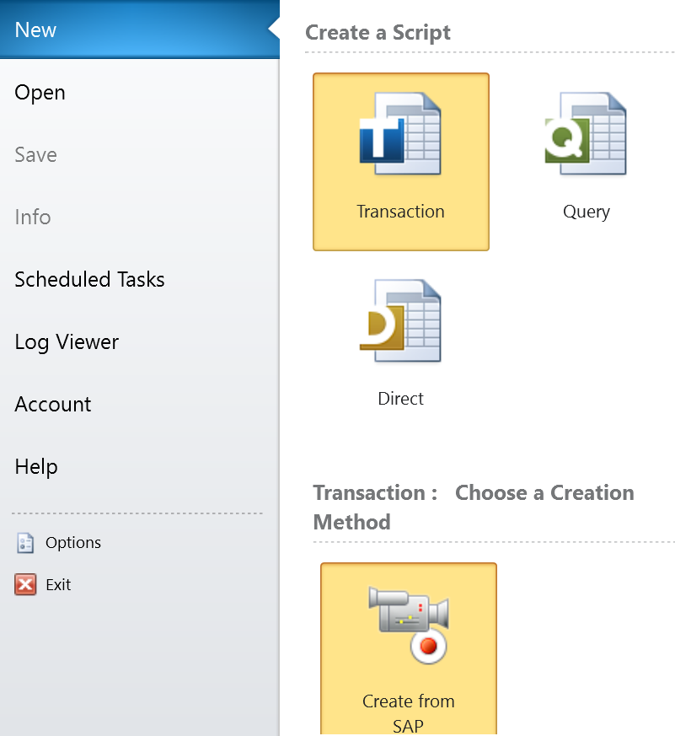

Next choose the SAP system to log on to.
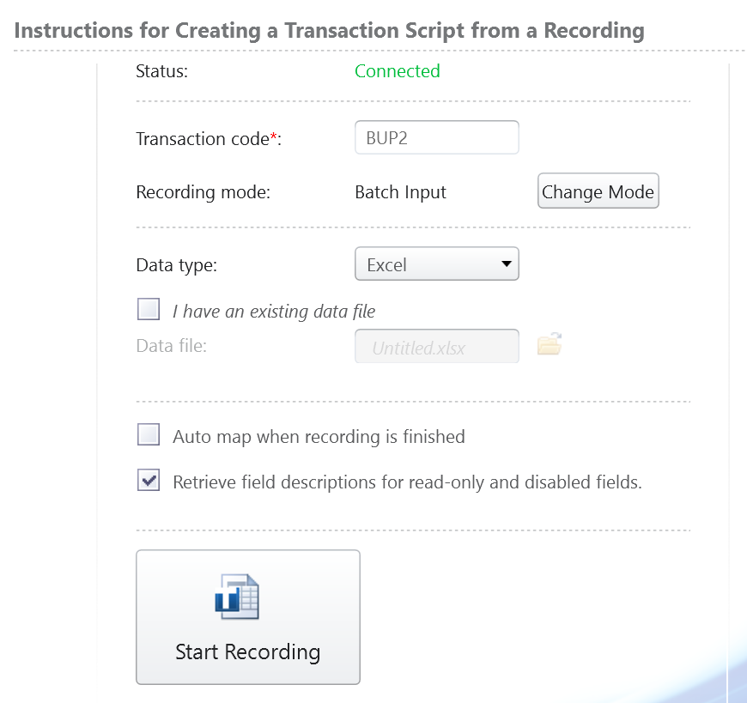
Enter the transaction Code BUP2. Click on Change Mode and then select Batch Input Mode.
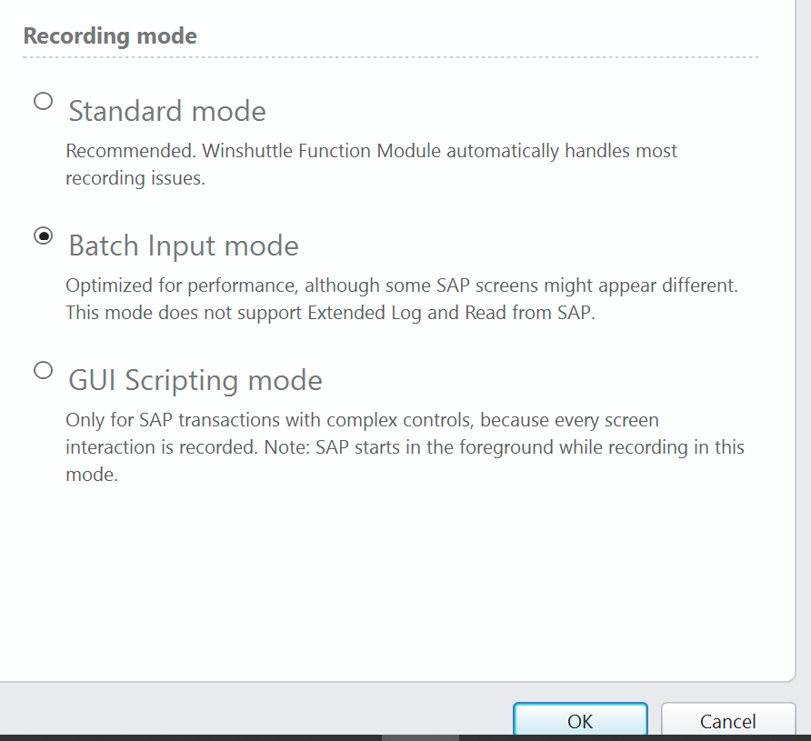
Record the transaction in the following steps:
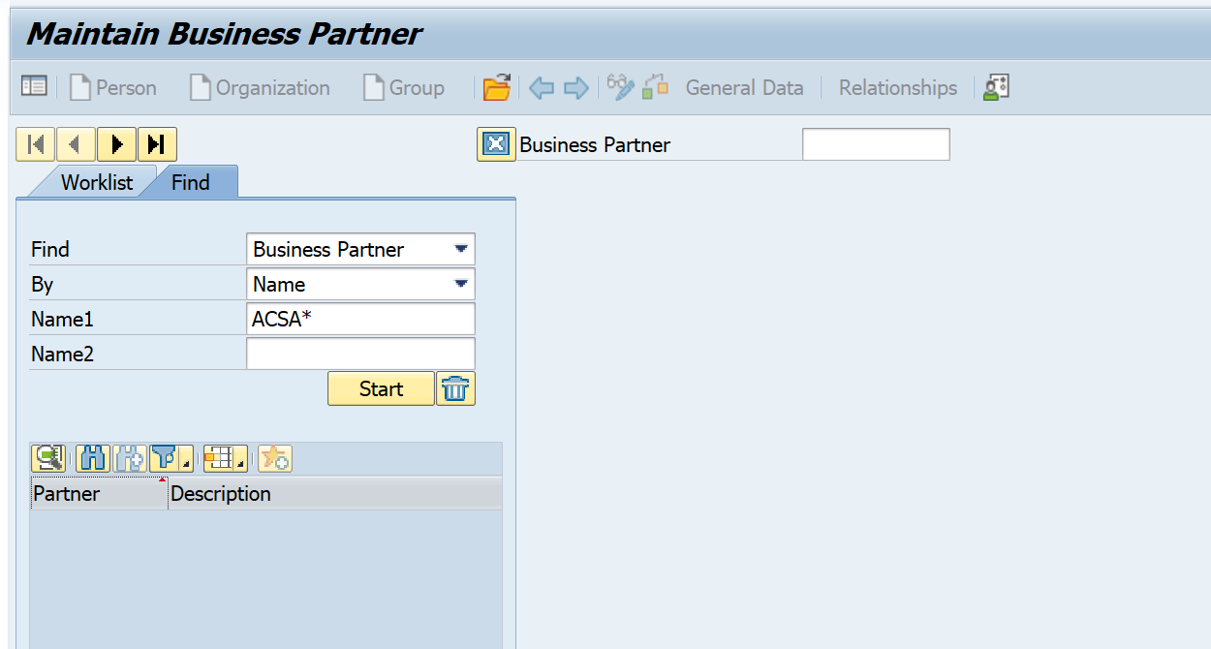
Do not enter the Business Partner number, but click on 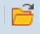 instead to open the pop-up.
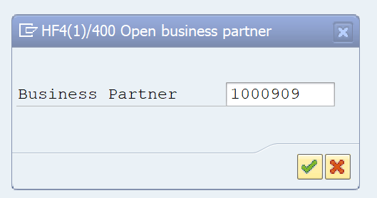
Enter the business partner number. (This is the number of your vendor or customer for whom you want to add contacts). Click on Enter.
The business partner should open in display mode. Click F6 to change from Display to Change mode. The business partner is now ready for editing. Click on .
The Relationship view is displayed.
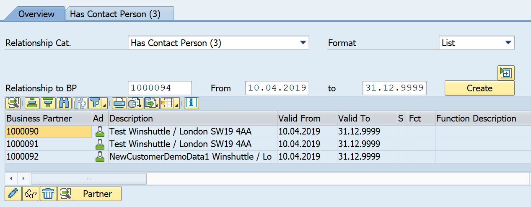
From the drop-down Relationship Cat, pick “Has Contact Person”. Enter the business partner number of the contact to assign in Relationship to BP. Enter the valid-from date in From and the valid-to date in to and then click on Create.
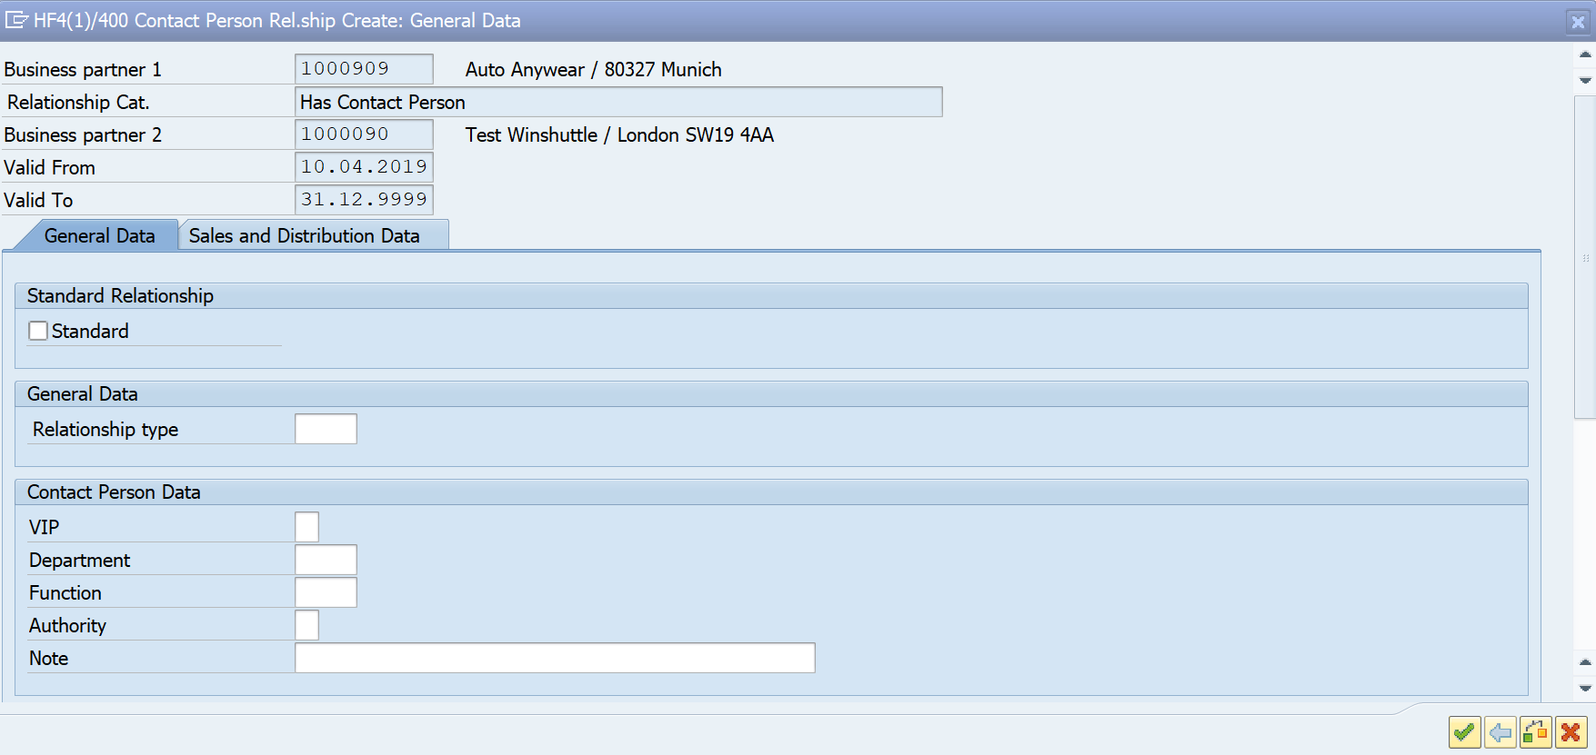
Click Enter.
The business partner is added to the list below.
Now we have to return the BUP2 transaction to the same state as it was when we entered the transaction. (BUP2 remembers where you left off and puts you at the same place when called subsequently).
So we navigate back by clicking on 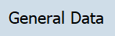. Now we are back on the Address screen in Edit mode. We need to return to display mode, therefore we click on F6.
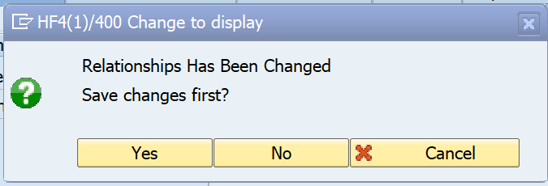
Click on Yes. This will exit the transaction and return control back to Studio.
In the second step in Studio, we will map the fields.
I used Auto-map 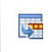to map all the fields.
The field BURS_JOEL_MAIN-DIRECTED_TYPE_C contains the drop-down of the check-box where we picked Has Contact Person. This field can be made into a Fixed value upload / and the column D deleted.
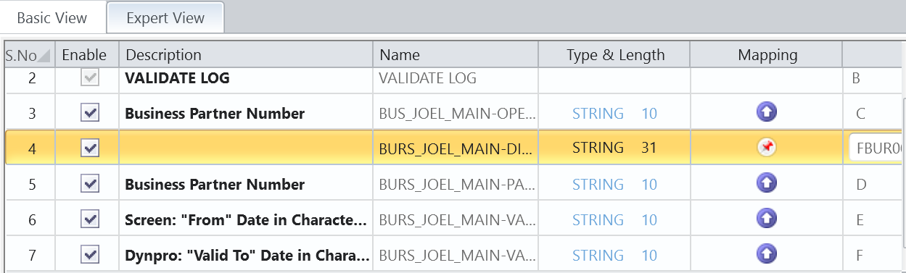
Final step: test the script.
On the Run Tab, under Run Settings, make sure that the Start SAP GUI checkbox is checked.

