Importing an Excel File into PgAdmin
By Carl Hemphill - Spatial Data Analyst - July 24, 2019
Sometimes working with data in Excel has its limitations on query functions and timeliness. This guide shows how to easily import an Excel file into PgAdmin. QGIS is a necessary platform to enable this process, whereas using PgAdmin itself for this procedure is more complicated. For ease of explanation and for visual purposes, the default PostgreSQL 10 server in PgAdmin and QGIS version 3.6.2 have been used for this guide.
1. Before beginning the process of importing an Excel file into PgAdmin, it is important to first edit the Excel file so PgAdmin will have an easier time reading it. Below are helpful tips:
- Use lower case
- No spaces, use underscores instead
- Save your excel file as a .csv
- Numbers should not be at the beginning of the filename
- All columns need a header
2. Open PgAdmin and either select or create a database and schema. For using an existing database and schema, please refer to Steps 9 and 10.
Create a new database and schema by:
- Connect to the PostgreSQL 10 server, right click on Databases and choose Create > Database (Figure i); give it a name of your choice. This guide uses the name xl.
- Create a schema by right clicking on the newly created xl database and then Create > Schema (Figure ii); give it a name of your choice. This guide uses the name excel.
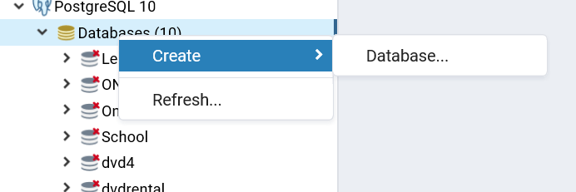
Figure ii
Figure i
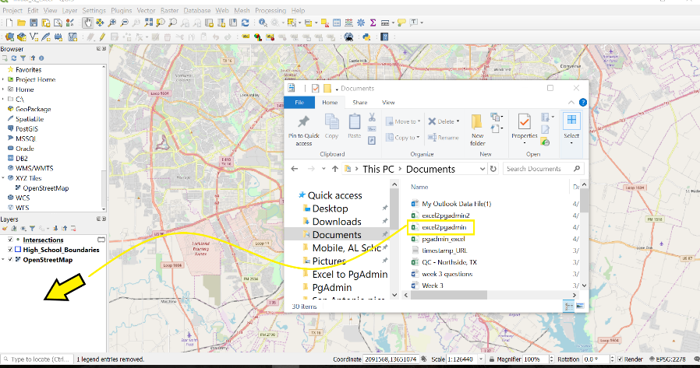
3. Open the 3.6.2 version of QGIS (also referred to as Q) and set up the screen to easily drag the Excel file into Q’s Layers window (Figure iii).

Figure iii
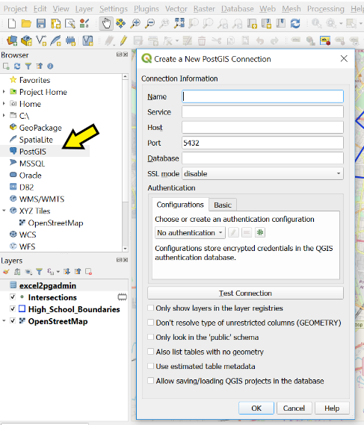
4. In the browser window (Figure iv), right click PostGIS > New Connection. Another window called Connection Information will open needing information found in PgAdmin.
Figure iv

5. Go back to PgAdmin and right click the PostgreSQL 10 server containing the xl database and click on Properties where the information is found for a simple copy/paste into Q’s Connection Information window:
- Copy/paste the server name found in the General tab (PostgreSQL 10)
- Click the Connection tab (fields might be gray) and copy/paste the Host name/address
- For Database, type in xl.
- Check the box Also list tables with no geometry > OK.
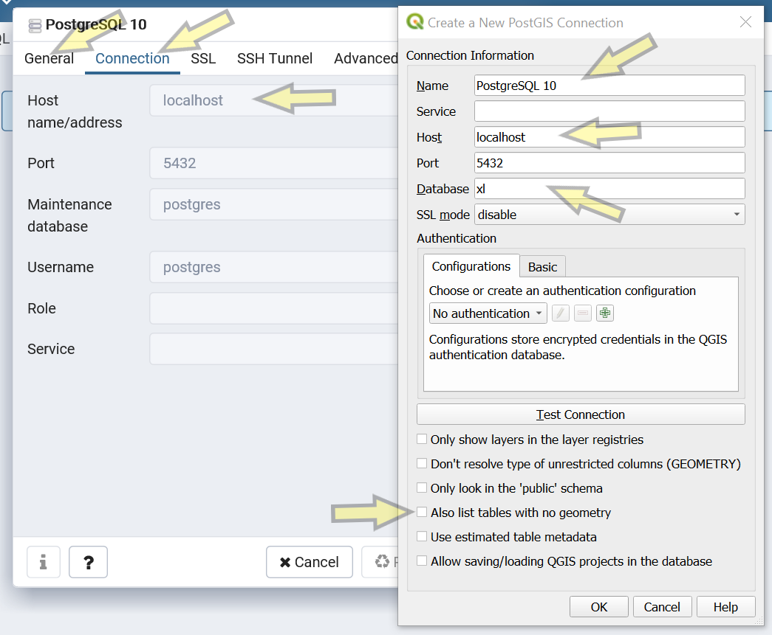
Figure v

6. Return to Q, click on PostGIS > PostgreSQL 10 (clicking the bullet points by the name works); a window should automatically open to enter username and password, which will be either the credentials given to you for access to a particular database, or what you used when you downloaded PostgreSQL 10. Note, if the window does not automatically open, then try right clicking on PostgreSQL 10 and select Refresh.

7. At the top of the page in Q, click on the Database tab (Figure vi):
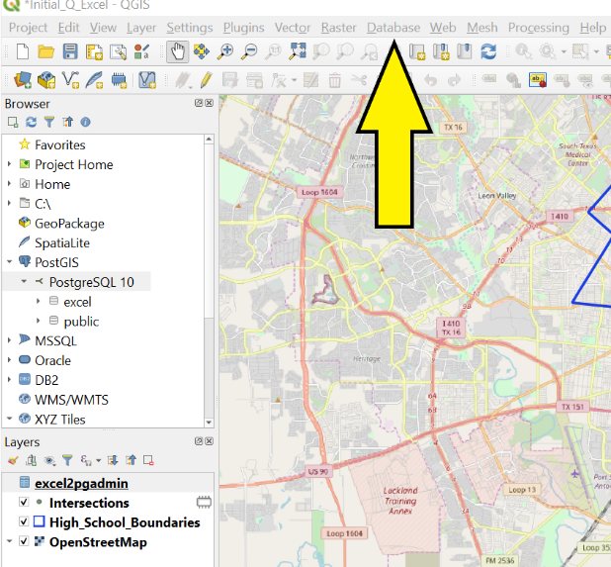
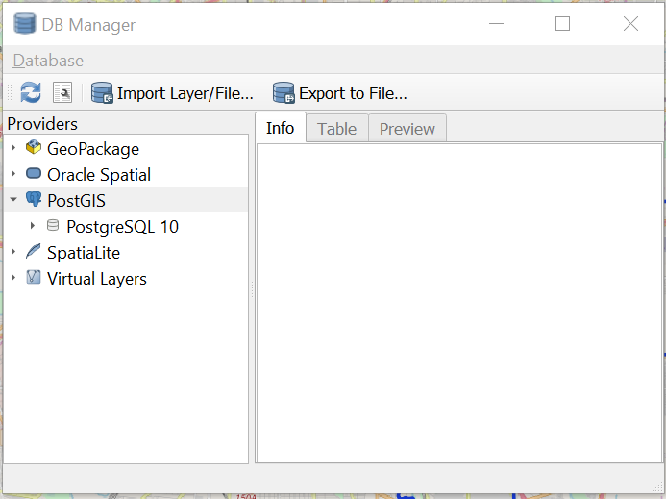
Figure vii
Figure vi

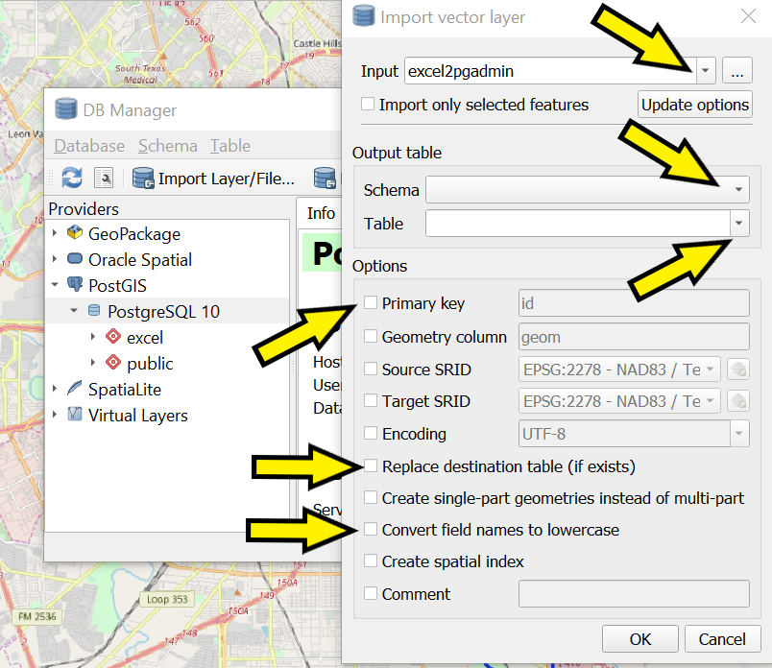
- Click on Database Manager > PostGIS (Figure vii);
Figure viii
- Enter your credentials, again.
- Click on the Import Layer/File. The Input dropdown will contain the files in Q’s Layers window which should include the Excel file (Figure viii).

- Under the Output table (Figures viii & ix):
- Select the Schema excel from the dropdown menu.
- Choose an appropriate name for the table: xl_test.
- Check the Primary key and enter the column name. Note, Q will automatically make a unique primary key, but for good habit’s sake, change the name to match the header of the primary key in the table (for example, ‘objectid’ and not the default ‘id’).
- Check the box for Replace destination table (if exists) as well as Convert field names to lowercase.
- OK.

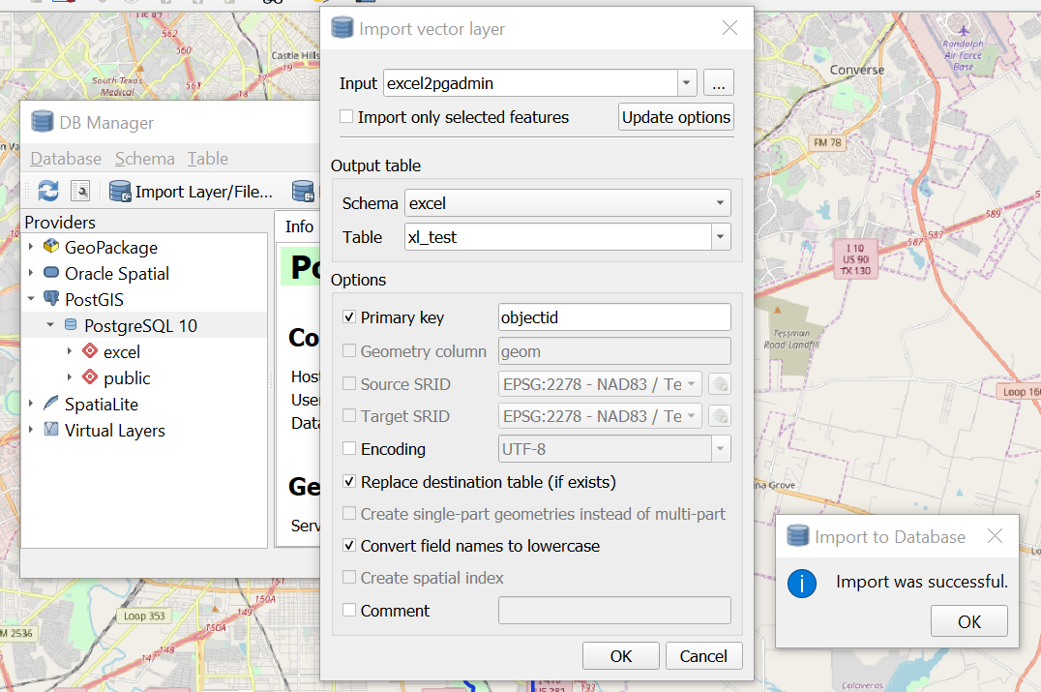
Figure ix

8. Go back to PgAdmin and verify the newly imported table!
9. You can easily add more tables to this newly created database and schema since Q has all of the credentials stored, just repeat steps 3 and 7.
10. For adding a table to an existing schema not already established in Q, follow steps 4 through 7 using the associated names of the server, database, and schema to correctly add the table.

