CR02 Work Center Updates for Capacity

SAP Easy Access - User Menu

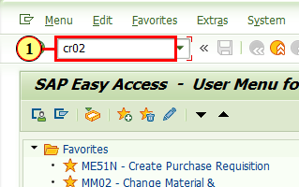

(1) To update work center capacities, enter CR02 in the command field and press enter.

Change Work Center: Initial Screen
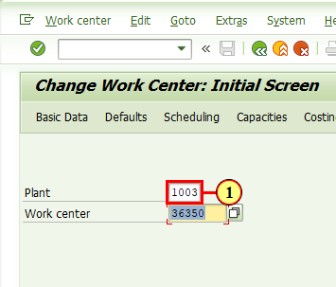
(1) Enter the Plant.

Change Work Center: Initial Screen

Enter the Work center to maintain, then press enter.

Change Work Center: Basic Data
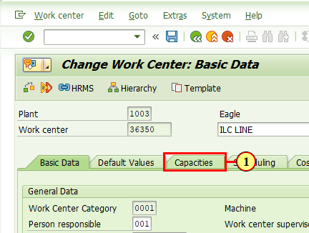
(1) Navigate to the Capacities tab.

Change Work Center: Capacity Overview
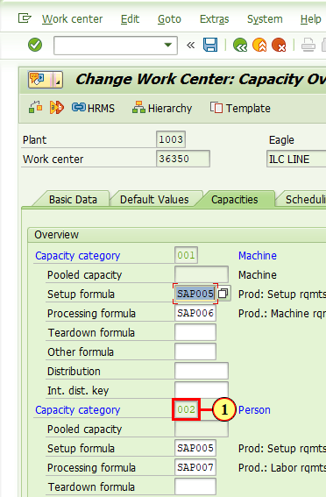
(1) Double-clicking in the input field Capacity category activates it.

Change Work Center Capacity: Header
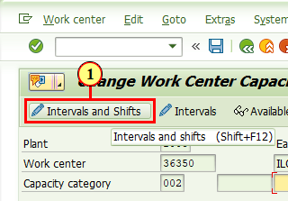
(1) Click Intervals and Shifts .
You can also press Shift+F12.

Change Work Center Capacity: Intervals of Available Capacity
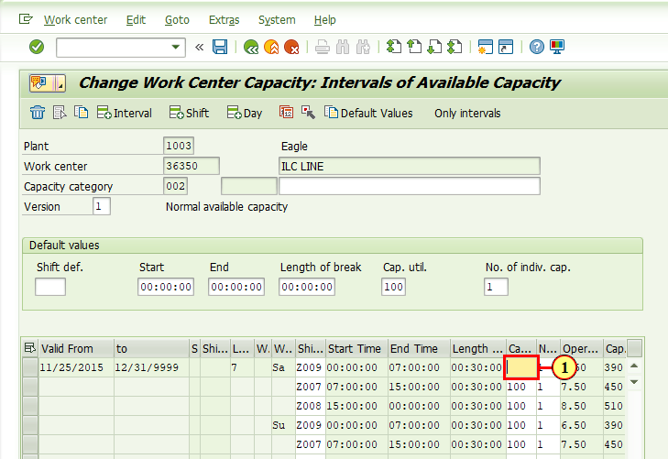
(1) Adjust the Cap. util. to the goal for efficiency in the department for each shift.

Change Work Center Capacity: Intervals of Available Capacity
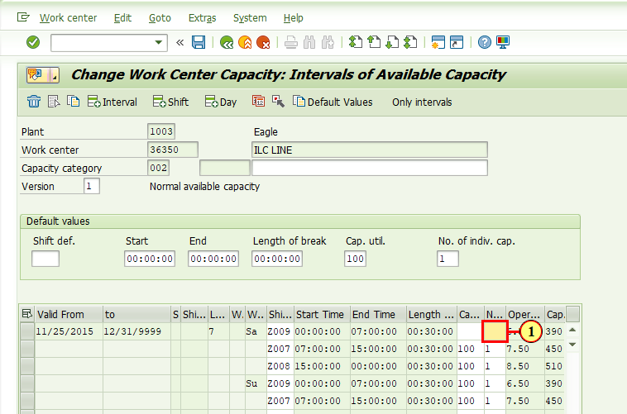
(1) Adjust the number of employees per shift.

Change Work Center Capacity: Intervals of Available Capacity
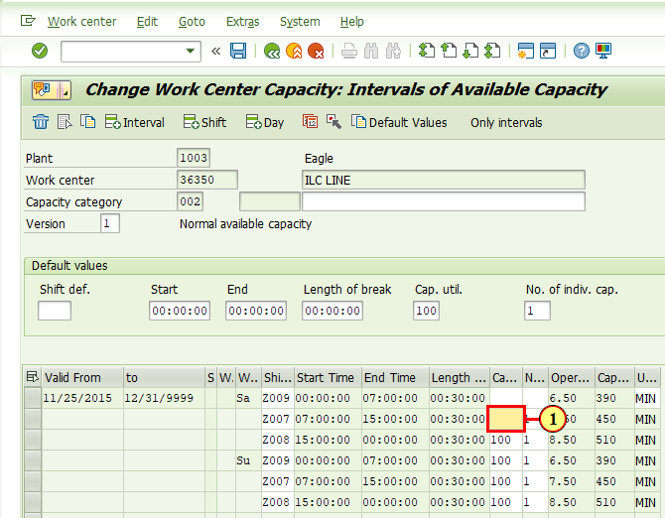
(1) Continue to adjust the Cap. util. for each shift until the entire schedule is updated.

Change Work Center Capacity: Intervals of Available Capacity
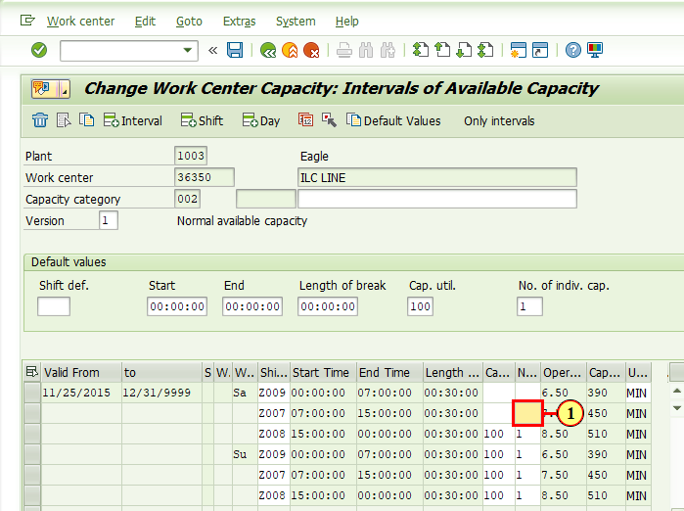
(1) Continue to adjust the Number of employees for each shift until the entire schedule is updated.

Change Work Center Capacity: Intervals of Available Capacity
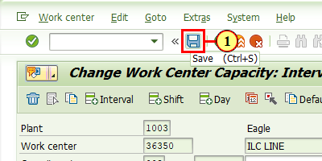
(1) Click Save .
You can also press Ctrl+S.

