**Create IBUY User ID**

* In SAP, open XD01 to create the Central Buyer
* Choose “0007 Sales partner” as the Account group, and make sure the Company code, Sales Organization, Distribution Channel, and Division populate as shown
* Enter the account number that corresponds with the address the customer provided on the registration form in the “Customer” field; enter Company Code, Sales Organization, Distribution Channel, and Division

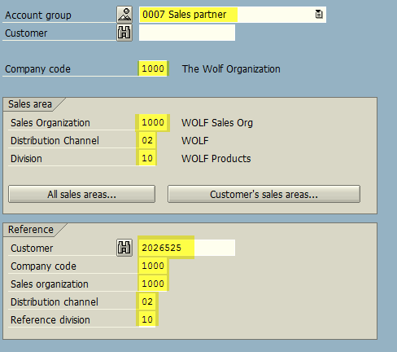

* Hit “Enter” or click the green checkmark

* Name field: the user’s name in the top line, and the account name in the second line
* Search terms: the account name in the first line, the user’s i-Buy ID in the second line
* Street address: the address provided on the registration form
* Add the email address in the Communication section
* Then click the “more fields icon” in the Name section to add the DBA

* Marketing tab: add IB in the Nielson ID

Company Code Data: Company Code 1000 should populate – no other entries needed

Sales Area Data: Sales Org 1000, Distr Channel 02, and Division 10 should populate—no other entries needed