Screenshots

BP Create Business Partner – General Data
SAP Transaction: BP  Click on ‘Create Organization’ | 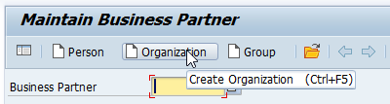
Click on 'Goto → Initial Screen' | 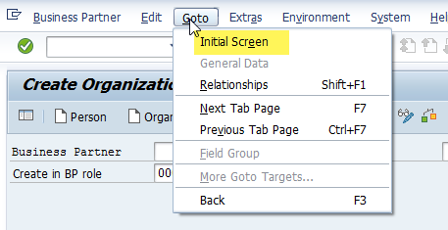
Click ‘Yes’ | 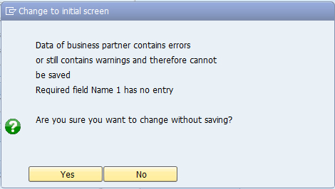
Click on Organization | 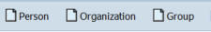
Select Grouping:  SP = Sold-to party | 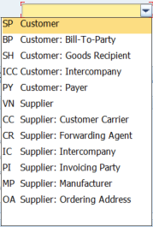
Choose 000000 Business Partner (Gen.) | 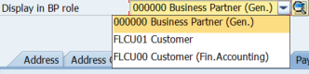
Address Tab:  Click on ‘Address’ tab button  Name  Name 1*  Name 2  Name 3  Name 4  Search Terms  Search Term 1  Search Term 2 | 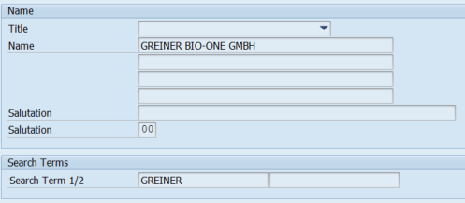  * Mandatory field
Expand Street Address section using the 'More fields' button  Street Address  Street 3  Street / House Number  Street 4  Street 5  Postal Code / City  Country (dropdown list)  Region (dropdown list)  Time zone (automatically completed)  Tax Jurisdiction  Transp. Zone (dropdown list) | 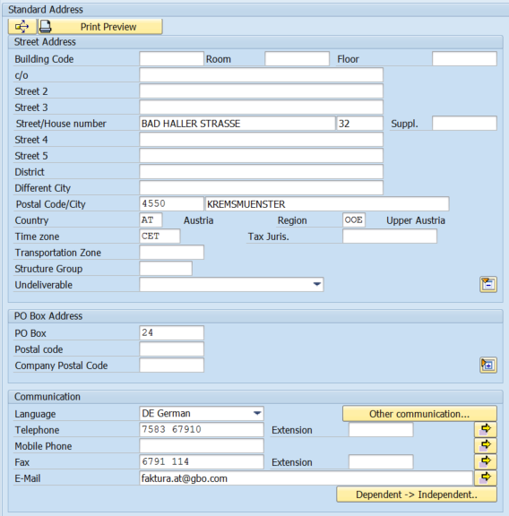
Communication
Language (dropdown list)
Telephone
Mobile Phone
Fax
E-Mail

Identification Tab:  Identification Numbers  External BP Number*  Tax Numbers  Tax Category (dropdown list)  Tax Number  Allow up to 4 entries  Click on ‘Payment Transactions’ tab button | 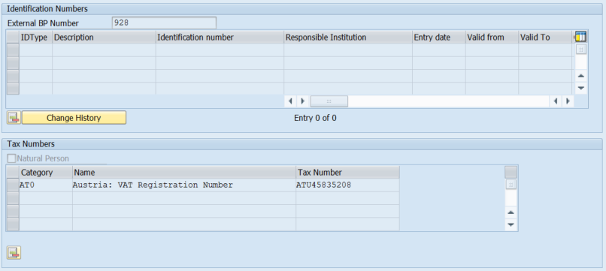
Payment Transactions Tab:

Bank Details
Country (dropdown list)
Bank Key
Bank Account
Control Key
IBAN

Click Save

