Step by step after switch to Non-Batch (with SAP controls) from Standard (Non-Batch with SAP controls)

BOM header info – OK
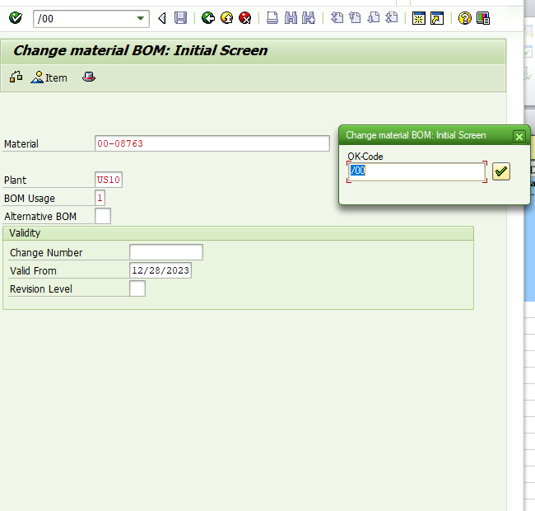

First component – OK
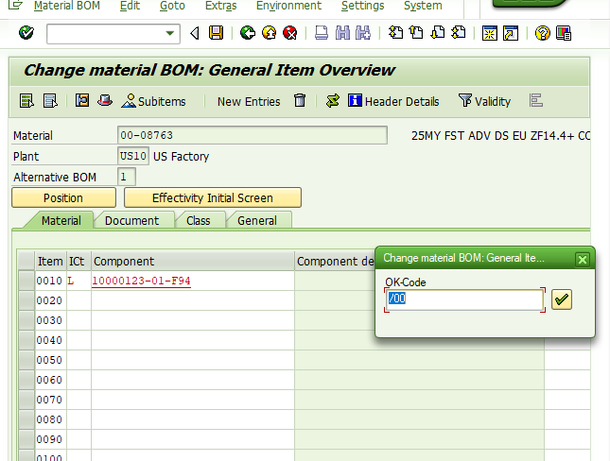

Enter through 1st subscreen – OK
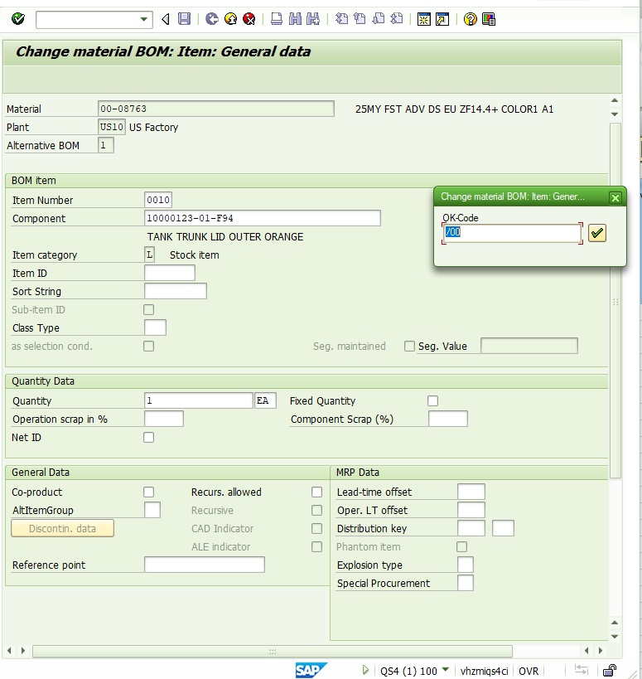
2nd subscreen – enter through OK
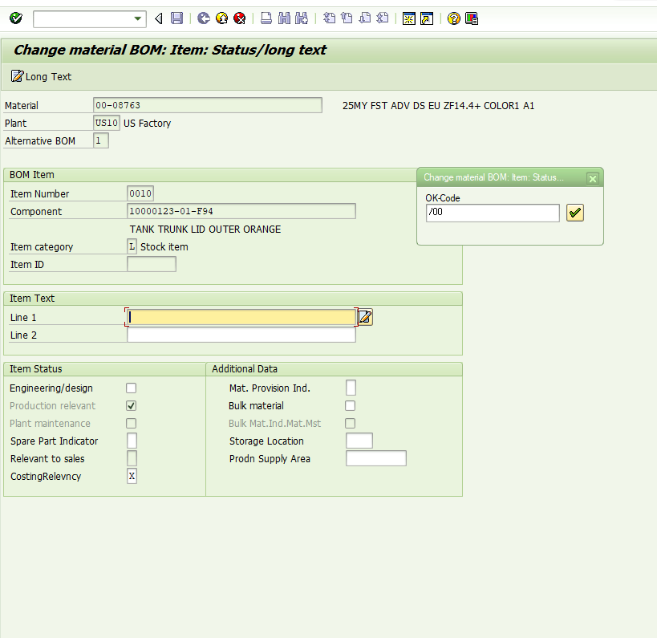
This is the hit the “new entries” button - OK
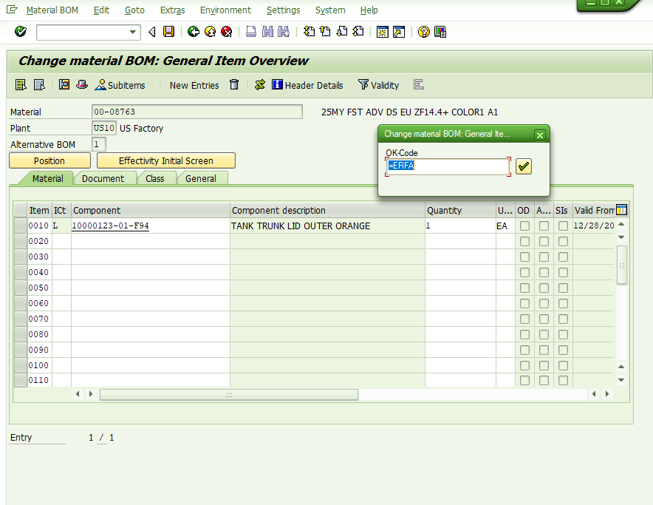

2nd component added – OK
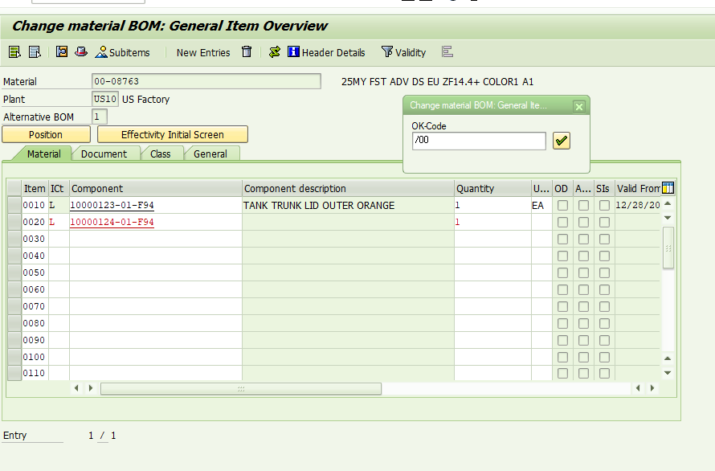

Second component 1st subscreen – OK through
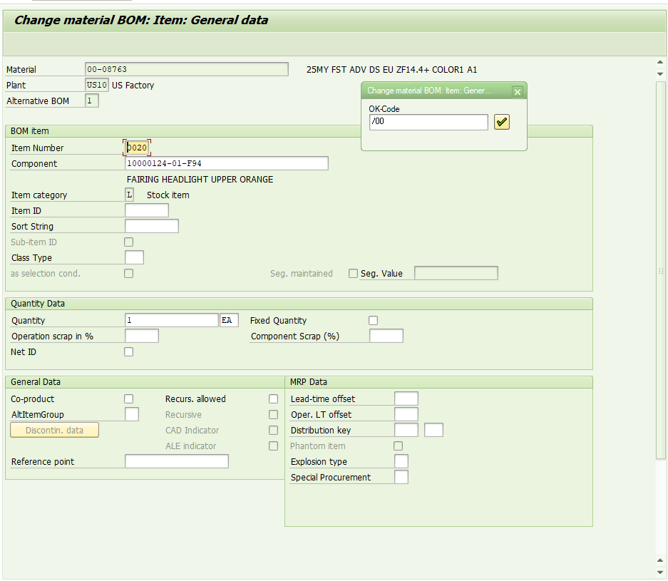

2nd component 2nd subscreen – shuttle stalls

