Cost Center Amendment for Goods & Service PO

- Open the intended Purchase Order for amendment by logging in to SAP, under me22n

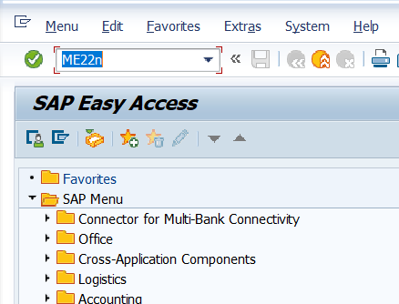

- Select the appropriate line item
- Determine whether the line item is for goods or services
- If Goods line item, select Account Assignment and replace the CC with the new one

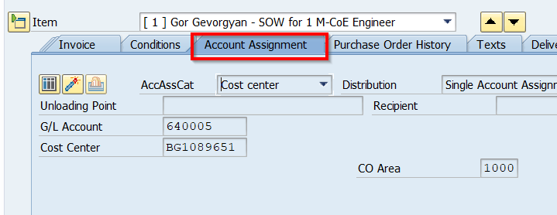

- If Service based PO select Service Tab and update the CC

- Select line item and update the Cost center number in Cost center Tab.

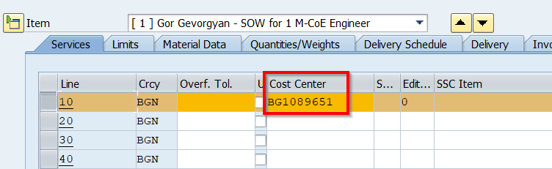

- Create a note and add a comment: “VCF Cost Center Mapping updates requested by GL Team”

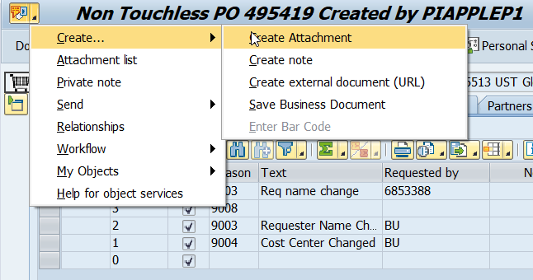

- Update the Version Management under Header

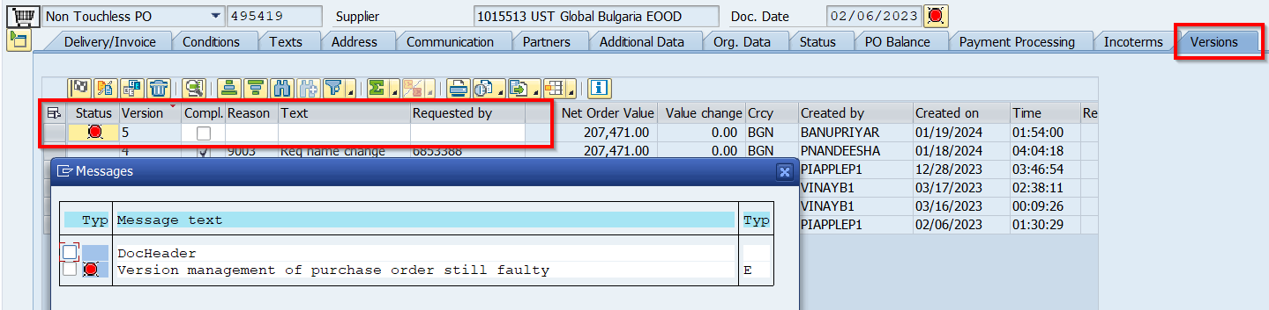
- Update Reason for change as 9004 in the Header

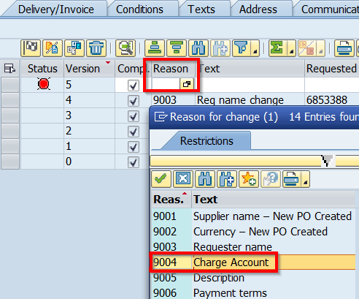
- Save the changes Done.

