Upcoming Change to List Display Formats

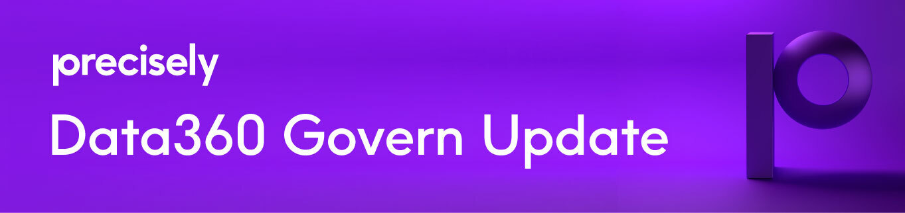

In the 2023 January February release of Govern there will be a change to list display formats. Details of the change are included in this announcement.

Why?
The reason we are doing this is to increase performance. There will be a noticeable increase in performance when adding new assets (POST) or editing existing assets (PUT).

What's Changing?
With the January 2023 release of Govern we will be updating the way display formats work on a list field type.
A list field is a type of custom field that can be added to assets, actions, or relationships. The various lists that can be added are a Reference list, Model list, Asset list, or Resource list.
Currently within each custom field you can designate a specific list display format and edit display format. This controls how the list item displays on the asset definition page and in the edit modal dialog.
In the January release we will be changing this so that the options for display formats on Reference lists, Model lists, and Asset lists are either:
- Display value of the Asset Type
- Asset Path
For Resource lists the options will be:
- Display value of Users
- User email address
Upon the release the default will be the Display value of the Asset Type or User, with the exception of Models lists that currently have a display format of TextPath. Those will default to the display of Asset Path.

What can be done now?
In preparation for this change there are few things you can do.
For Reference lists, Asset lists or Model lists:
- First identify what lists are used where. Determine if you have different list display formats for the same reference, asset, or model list in different places. If so, determine the preferred display and update that Asset Type’s display format.
- If you are satisfied with the existing Asset Type’s display format, then no changes are necessary.
For Resource lists:
- While not seen currently, there is a User display format. We will be exposing that in the UI upon releasing this change. It will default to {First Name} {Last Name}.
- Identify where you have Resource Lists and determine what display format you prefer. You will be able to update that to the User display format with the release.

Need help?
If you have questions or need assistance in identifying the changes you need to make, please contact your Customer Success Representative. They will set up a time to review your setup.

Example:
Below is an example of what to update and the change.
For the Reference List ‘Application Priority’ the current Reference List Type display format is {code}:

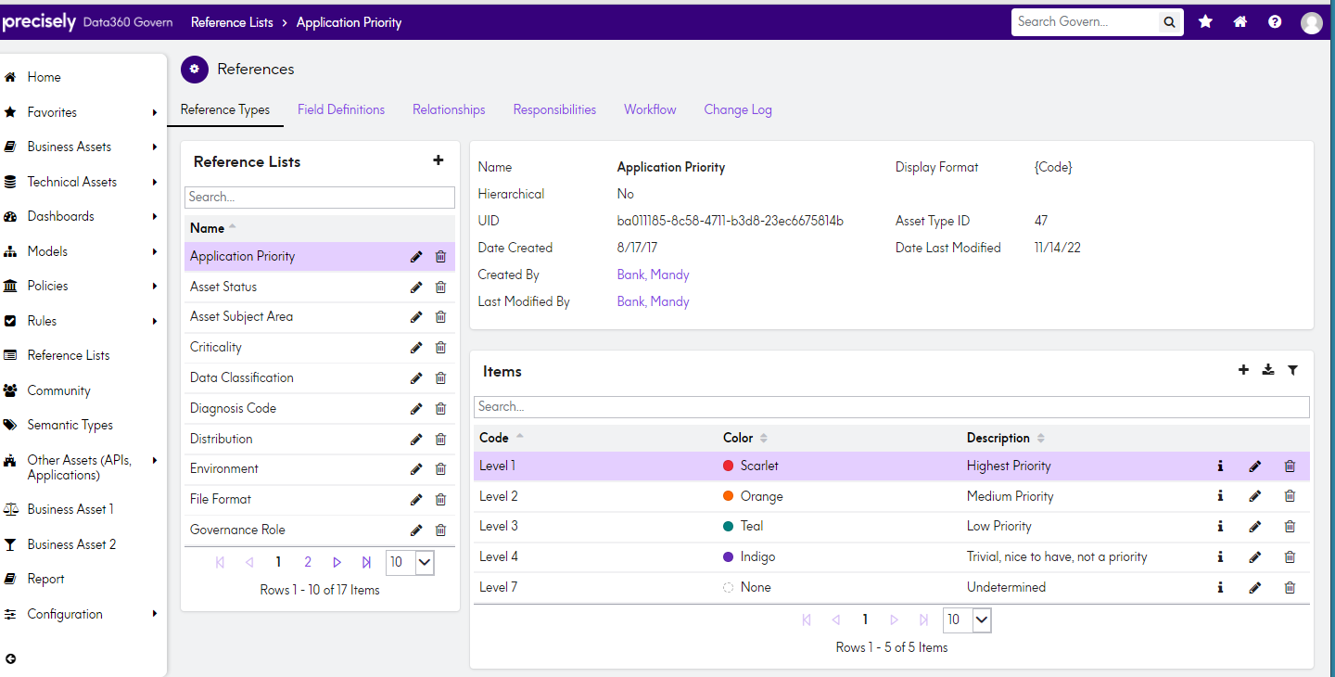

This Reference List is currently used on an asset type:
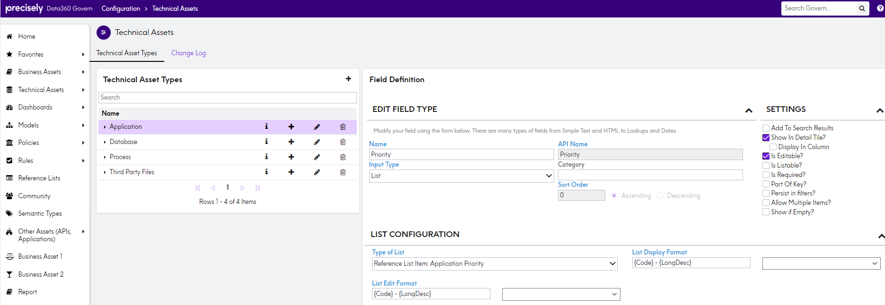
Update the Reference List Type display format:
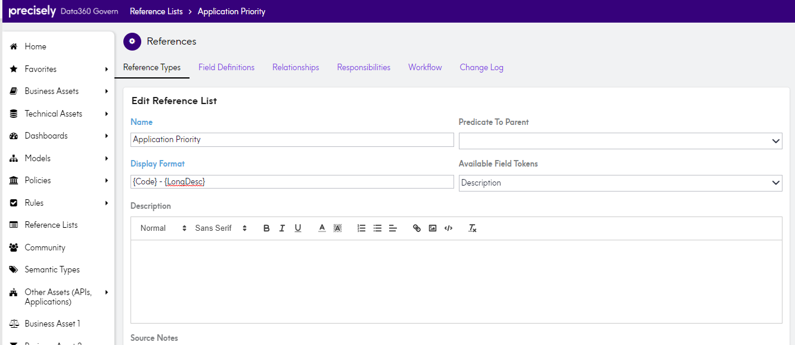
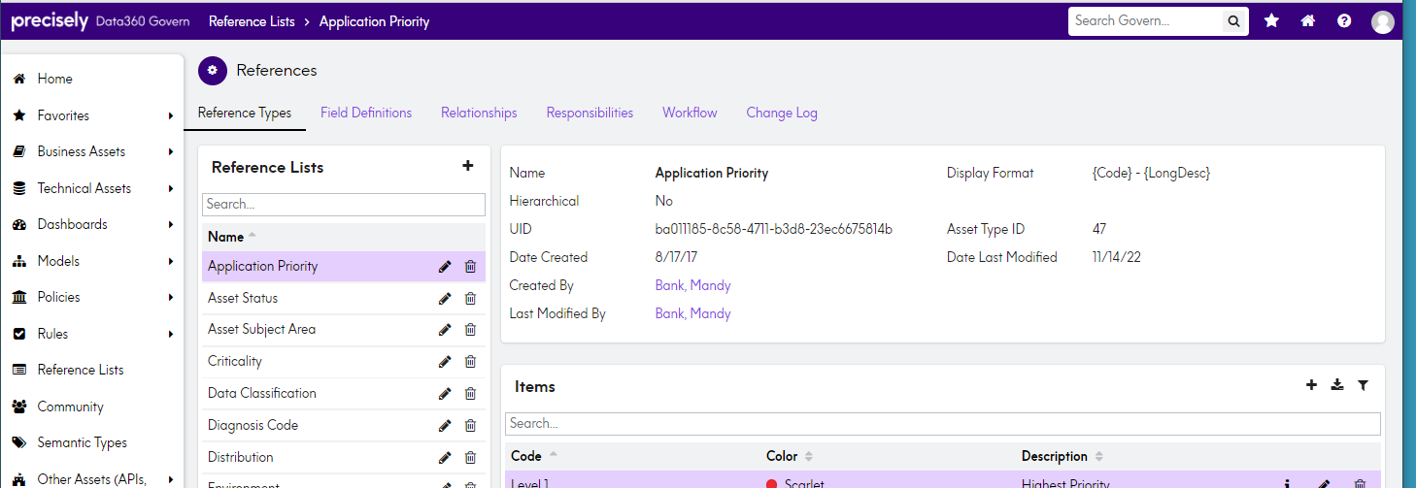
This update can occur now. It does not need to happen with the January release. When the January release happens then your list field will appear similar to this: 