By default my lookup looks like this:
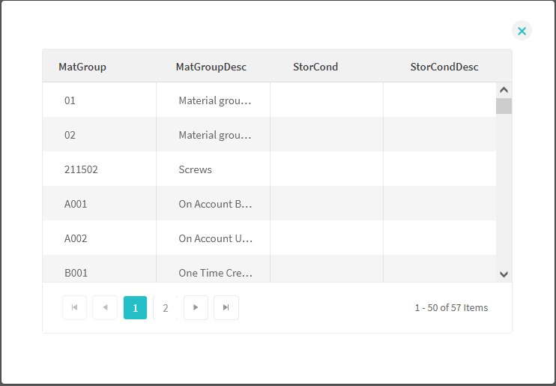
Edit the solution’s style definitions: Solution -> Custom Styles…
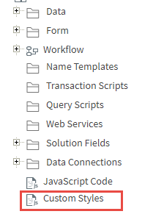
Add the following rows in custom styles:
.c-kendo-grid .k-grid td {
padding: 1px 1px !important;
}
.k-header {
padding: 2px 6px !important;
}

Result is now:
